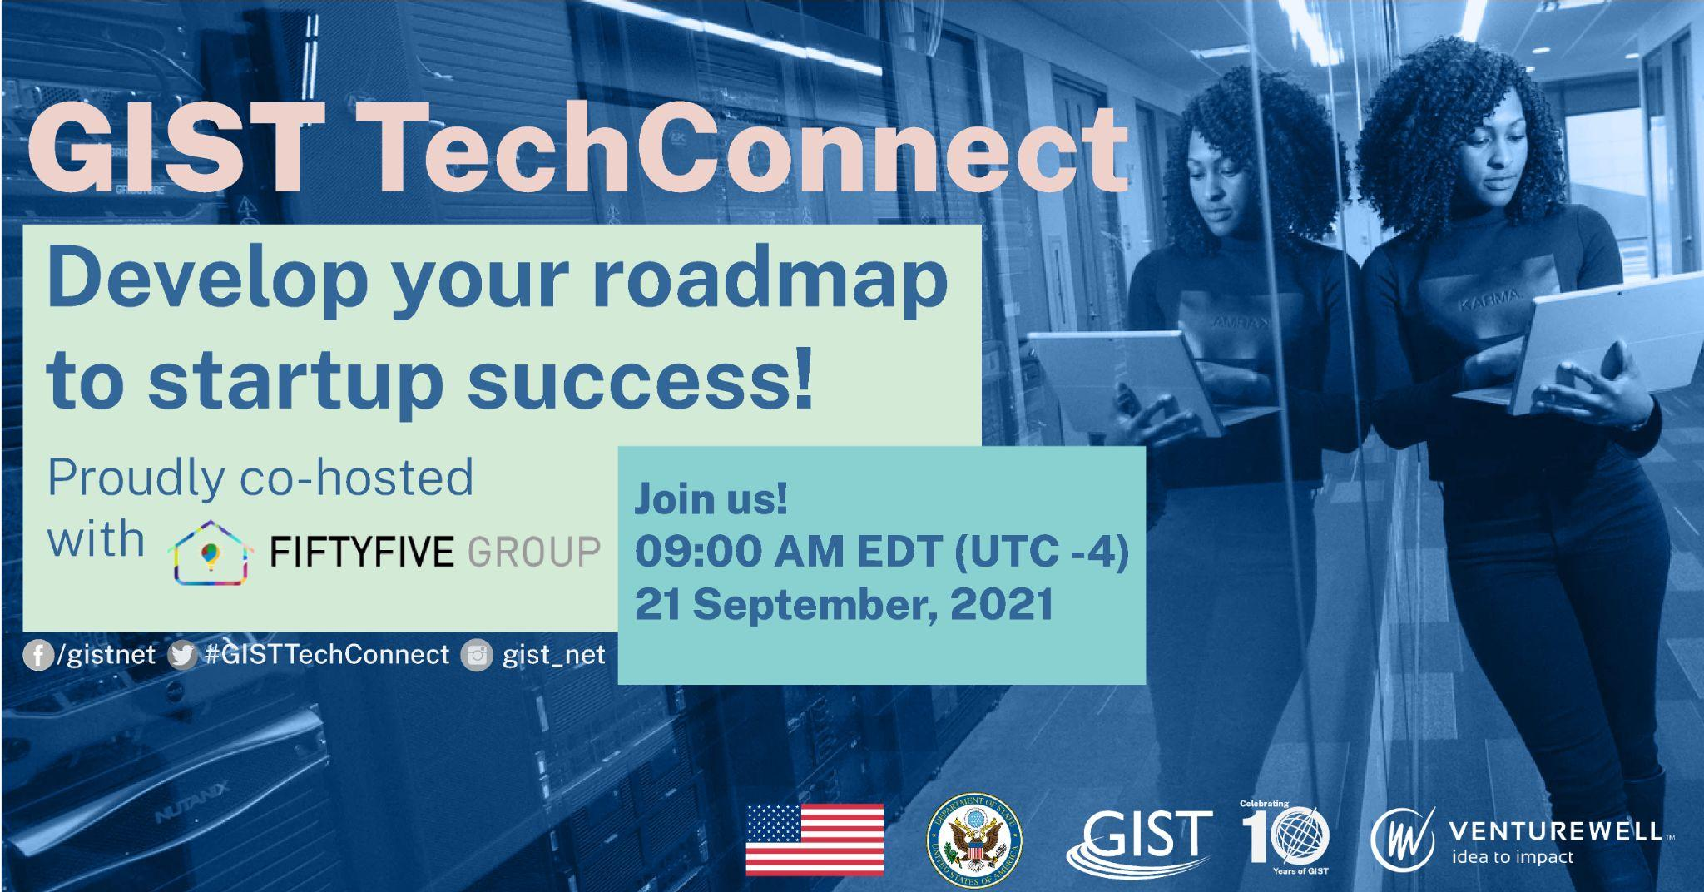

About GIST TechConnect
GIST TechConnects provide entrepreneurs around the world with direct access to leading U.S. experts from business and academia, but without the travel and other related costs. Young science and technology entrepreneurs can engage with experts and the larger GIST community to learn about best business practices and startup resources.

GIST TechConnect: “Develop Your Roadmap to Startup Success!”
21 September, 09:00 AM Eastern Time (UTC -4)

Program Description
Here at GIST, we are constantly evolving to meet the ever-changing needs of innovators all over the world. We know that these are unprecedented times and thus we are working around the clock to bring you the resources you really need to succeed. To further accomplish this, for this quarter’s TechConnect we have partnered with a dynamic GIST Innovation Hub, our in-country resource hubs for entrepreneurs, to help you develop a tried-and-true roadmap to startup success!

55 Group, our IHub out of Tajikistan, began as a collective of entrepreneurs who came together to support their country’s relatively young innovation ecosystem. They’ll be sharing their expertise, gained by pioneering incubator programs, on the steps early-stage startups go through to build marketable and scalable products. 55 Group will join our U.S-based expert panelists to walk you through the steps to plan out your startup’s roadmap to success.

So, whether it’s team-building, fundraising, marketing, or product development, building a strong network to utilize can be critical for startup success. But how do you build a strong network? What resources might already be available to you? And then, once the network is built, how do you use that network to achieve your goals? We’ll be answering those questions, and more, to give you the tools to build your own network and maximize its potential. We’ll also be providing you with the same worksheet that we give to the startups that go through our training programs so that you can map out your plan in real-time. During this interactive session, our expert panelists will explain the benefits of a strong network and walk you through their recommendations for how to activate it. You can use the worksheet to plan your own path forward to success. Join us for this interactive live event!

PANELISTS

Ravshan Kurbanov, 55 Group

Dawn Batts, TechTown Detroit

Additional Panelists TBD

Moderator TBD

SOCIAL POSTS

Twitter
Tune in on 21 September for 🎥 #GISTTechConnect: “Develop Your Roadmap to Startup Success!” Learn the critical activities on your path 🗺 to launch 🚀, like building a strong network, marketing, fundraising, product development & more! Join here: https://bit.ly/2W8vDi1

Facebook
Tune in on 21 September at 9am ET for 🎥 #GISTTechConnect: “Develop Your Roadmap to Startup Success!” Learn about the critical activities on your path 🗺 to launch 🚀, like building a strong network, marketing, fundraising, product development & more! Members of 🇹🇯 #Tajikistan IHub 55 Group and US-based experts will be on hand to answer your questions during this live, interactive event! Join: https://bit.ly/2W8vDi1

Twitter
Are you a company mapping 🗺 your path to launch? Join us on 21 September for #GISTTechConnect: “Develop Your Roadmap to Startup Success!” Get the advice you need to plan your next steps during this conversation co-hosted by 🇹🇯#Tajikistan IHub 55 Group! https://bit.ly/2W8vDi1

Facebook
Are you a company mapping your path to launch? Join us on 21 September at 9am ET for 🎥#GISTTechConnect: “Develop Your Roadmap to Startup Success!” to get the advice and hands-on tools you need to plan your next steps. During this conversation co-hosted by 🇹🇯#Tajikistan IHub 55 Group, our expert panelists will explain the benefits of a strong network 🌐 and walk you through their recommendations for how to activate it! Tune in: https://bit.ly/2W8vDi

Twitter
On the next #GISTTechConnect on 21 September, get the tips you need to build your network & maximize its potential! You’ll gain access to tools used in our startup trainings during this live, interactive event. Get ready to map out your path to market! https://bit.ly/2W8vDi1

Facebook
On the next 🎥#GISTTechConnect on 21 September at 9am ET, get the tips you need to build your network 🌐 & maximize its potential! You’ll gain access to tools used in our startup trainings during this live, interactive event. Learn more about topics like team-building, marketing, fundraising, and more. Get ready to map out your path to market! https://bit.ly/2W8vDi1

Twitter
@GISTNetwork has been supporting #innovators around the 🌎 for 🔟 years—now let them help YOU chart your path to market! Tune in on 21 Sept @ 9am ET for #GISTTechConnect “Develop Your Roadmap to Startup Success!” co-hosted by #Tajikistan IHub 55 Group https://bit.ly/2W8vDi1

Facebook
@GISTNetwork has been supporting #innovators around the world for a decade—now let them help YOU chart your path to market! Tune in on 21 September at 9am ET for #GISTTechConnect discussion “Develop Your Roadmap to Startup Success!” co-hosted by 🇹🇯 #Tajikistan IHub 55 Group. They will discuss the critical importance of building and leveraging your own network during this live event! Learn more: https://bit.ly/2W8vDi1

Twitter
(1/2) Join GIST live on 21 September at 9am ET to hear from 🇹🇯 #Tajikistan IHub 55 Group and US-based expert panelists as they help you develop a tried-and-true roadmap to #startup success!

(2/2) This deep dive #GISTTechConnect discussion will cover critical #startup topics like team-building, #networking 🌐, #marketing, #fundraising! We’ll see you there! https://bit.ly/2W8vDi1

Facebook
Join GIST live on 21 September at 9am ET to hear from 🇹🇯 #Tajikistan IHub 55 Group and US-based expert panelists as they help you develop a tried-and-true roadmap 🗺 to startup success! This deep dive #GISTTechConnect discussion will cover critical #startup topics like team-building, networking, marketing, fundraising! We’ll see you there! https://bit.ly/2W8vDi1

