GIST TechConnect: “Building Your Startup from the Ground Up”
Social sharing kit

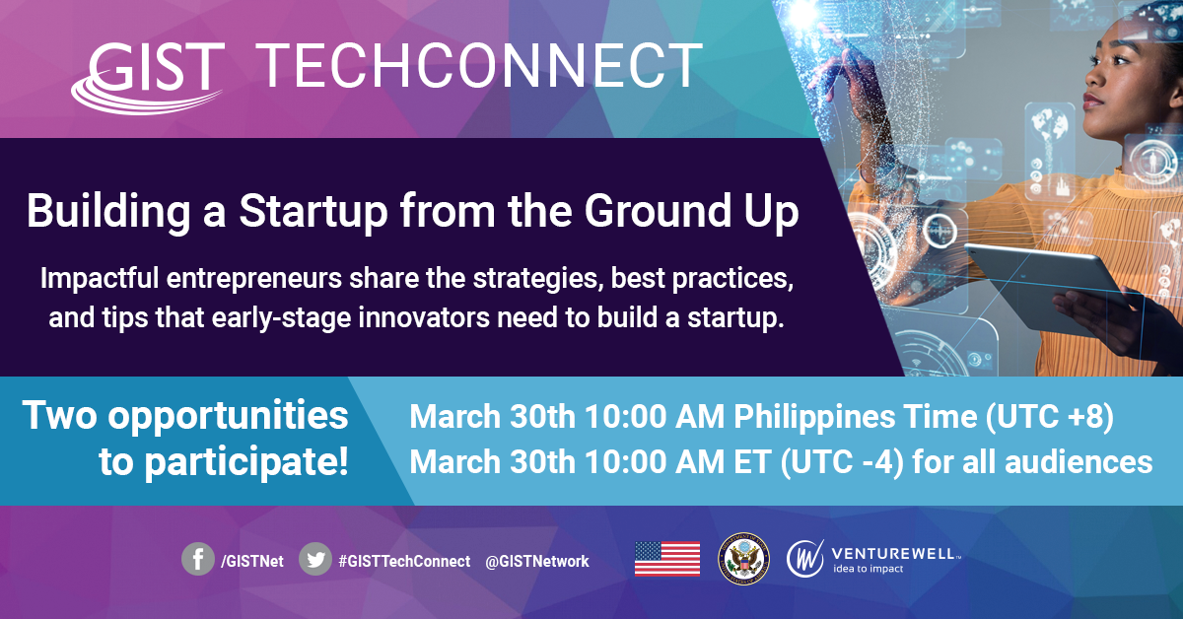

About GIST TechConnect
GIST TechConnects provide entrepreneurs around the world with direct access to leading U.S. experts from business and academia, but without the travel and other related costs. Young science and technology entrepreneurs can engage with experts and the larger GIST community to learn about best business practices and startup resources.

“Building Your Startup from the Ground Up”
March 30th 10:00 AM PHT (UTC +8)
March 30th 10:00 AM ET (UTC -4)
There are many approaches to launching and growing a successful venture. Clearing the hurdles on your path to success—from developing the idea for your solution, to determining product/market fit, to overcoming gender bias — can be daunting. We’ll sit down with a group of impactful entrepreneurs who will share the strategies, best practices, and tips that early-stage innovators can use to set them on a path to growth and success.

Panelists
Ting Shih, CEO & Founder, ClickMedix @ClickMedix
Nina Dudnik, founder Seeding Labs @Nina_Dudnik

Moderator
Kristina Francis, Executive Director, JFFLabs @esteem_logic

SOCIAL POSTS

Twitter
On 30 March 🗓, join #GISTTechConnect for a spotlight on building your startup from the ground up with Ting Shih @ClickMedix, Nina Dudnik @Nina_Dudnik & Kristina Francis @esteem_logic. Two chances to join: 10:00 am PHT (UTC +8) or 10:00 am ET (UTC -4)! https://bit.ly/3bCWdox

Facebook
Mark your calendars! 🗓 On 30 March, join us for @GISTNet’s #GISTTechConnect episode “Building Your Startup from the Ground Up” with Ting Shih of @ClickMedix and Nina Dudnik @Nina_Dudnik of Seeding Labs, moderated by Kristina Francis of @esteem_logic. Learn more about finding your inspiration and overcoming obstacles on your way to launching 🚀 your business! Two chances to tune in: 10:00 am PHT (UTC +8) or 10:00 am ET (UTC -4). #womenshistorymonth https://bit.ly/3bCWdox

Twitter
Save the date for the next #GISTTechConnect on 30 March! 🎥 Join GIST for a new episode on building your startup! We’ll share the strategies that early-stage innovators need to grow their company! Bring questions—experts will answer them LIVE! https://bit.ly/3bCWdox

Facebook
Save the date for the next #GISTTechConnect on 30 March! 🎥 Join GIST for a new episode on building your startup! Speakers Ting Shih @ClickMedix, Nina Dudnik @Nina_Dudnik, and Kristina Francis @esteem_logic share the strategies that early-stage innovators need to grow their company! Bring questions—experts will answer them LIVE! Two chances to join: 10:00 am PHT (UTC +8) or 10:00 am ET (UTC -4). #womenshistorymonth https://bit.ly/3bCWdox

Twitter
[1/2] Are you an #entrepreneur looking to grow your company? Join Ting Shih @ClickMedix, Nina Dudnik @Nina_Dudnik, and Kristina Francis @esteem_logic on 30 March for the #GISTTechconnect “Building Your Startup from the Ground Up”! https://bit.ly/3bCWdox

[2/2] They’ll share the strategies & best practices that early-stage #innovators need to set them on a path to growth and success. Two chances to watch: 10:00 am PHT (UTC +8) or 10:00 am ET (UTC -4).

Facebook
Are you an entrepreneur looking to grow your company? Join Ting Shih @ClickMedix, Nina Dudnik @Nina_Dudnik, and Kristina Francis @esteem_logic on 30 March for the #GISTTechconnect “Building Your Startup from the Ground Up”! They’ll share the strategies & best practices that early-stage innovators need to set them on a path to growth and success. Bring your questions—they’ll be answered LIVE during the event! Two chances to watch: 10:00 am PHT (UTC +8) or 10:00 am ET (UTC -4). #womenshistorymonth https://bit.ly/3bCWdox

Twitter
On the next #GISTTechConnect, speakers from @ClickMedix, @Nina_Dudnik & @esteem_logic share how to clear the hurdles to #startup success, from building your team to finding your first customers! 30 March at 10:00 am PHT (UTC +8) or 10:00 am ET (UTC -4). https://bit.ly/3bCWdox

Facebook
On the next #GISTTechConnect, “Building Your Startup from the Ground Up” speakers from ClickMedix, Seeding Labs, and EsteemLogic share how to clear the hurdles to startup success, from building your team to finding your first customers! Join GIST at 10:00 am PHT (UTC +8) or 10:00 am ET (UTC -4). #womenshistorymonth https://bit.ly/3bCWdox

Twitter
Join an impactful group of entrepreneurs for #GISTTechconnect’s “Building Your Startup from the Ground Up”! Gain expert advice, find inspiration & overcome obstacles to launching your company! Join 30 March at 10:00 am PHT (UTC +8) or 10:00 am ET (UTC -4). https://bit.ly/3bCWdox

Facebook
Join impactful entrepreneurs Ting Shih @ClickMedix, Nina Dudnik @Nina_Dudnik, and Kristina Francis @esteem_logic for #GISTTechconnect’s “Building Your Startup from the Ground Up”! Gain expert advice, find inspiration & overcome obstacles to launching your company! Join 30 March at 10:00 am PHT (UTC +8) or 10:00 am ET (UTC -4). #womenshistorymonth https://bit.ly/3bCWdox

Twitter
Tune in for tomorrow’s #GISTTechConnect on building your #startup with entrepreneurs Ting Shih @ClickMedix, Nina Dudnik @Nina_Dudnik & Kristina Francis @esteem_logic. GIST will answer your questions live! 10:00 am PHT (UTC +8) or 10:00 am ET (UTC -4) https://bit.ly/3bCWdox

Facebook
Tune in tomorrow for “Building Your Startup from the Ground Up” a #GISTTechConnect 🎥discussion focused on best practices for building your startup! Hear advice from entrepreneurs Ting Shih from @ClickMedix, Nina Dudnik from @Nina_Dudnik, and Kristina Francis from @esteem_logic. Be sure to bring your questions—GIST will answer them live! Watch at 10:00 am PHT (UTC +8) or 10:00 am ET (UTC -4) #womenshistorymonth https://bit.ly/3bCWdox

